NM DATA ANALYTICS ASSIGNMENT 3 - House Price dataset of India TEAM ID : NM2023TMID07243

DONE BY KAVITHA K

# Importing the necessary libraries for EDA and data preprocessing

|  |  |  |
| --- | --- | --- |
| In [2]: | | **import** pandas **as** pd  **import** numpy **as** np  **import** matplotlib.pyplot **as** plt  **import** seaborn **as** sns  **import** folium |
|  |  | **from** scipy **import** stats |
|  |  | **Converting csv file into dataframe** |
| In | [3]: | df**=**pd**.**read_csv('C:/Users/surya/Downloads/House Price India.csv') |
|  |  |  |
| In | [4]: | df**=**df**.**drop(['Date'],axis**=**1) |
|  |  |  |
| In | [5]: | df |

Out[5]:

**number**

**id of**

**number of**

**living**

**lot**

**number**

**of**

**waterfront**

**number**

**of**

**condition**

**of the**

**grade of the**

**... Built**

**Renovation**

**Postal**

|  |  |  |  |  |  |  |  |  |  |
| --- | --- | --- | --- | --- | --- | --- | --- | --- | --- |
|  | **bedrooms bat** | **hrooms** | **area area** | **floors present** | **views** | **house** | **house Year** | **Year** | **Code** |
| **0** | 6762810145 5 | 2.50 | 3650 9050 | 2.0 0 | 4 | 5 | 10 ... 1921 | 0 | 122003 |
| **1** | 6762810635 4 | 2.50 | 2920 4000 | 1.5 0 | 0 | 5 | 8 ... 1909 | 0 | 122004 |
| **2** | 6762810998 5 | 2.75 | 2910 9480 | 1.5 0 | 0 | 3 | 8 ... 1939 | 0 | 122004 |
| **3** | 6762812605 4 | 2.50 | 3310 42998 | 2.0 0 | 0 | 3 | 9 ... 2001 | 0 | 122005 |
| **4** | 6762812919 3 | 2.00 | 2710 4500 | 1.5 0 | 0 | 4 | 8 ... 1929 | 0 | 122006 |
| **...** | ... ... | ... | ... ... | ... ... | ... | ... | ... ... ... | ... | ... |
| **14615** | 6762830250 2 | 1.50 | 1556 20000 | 1.0 0 | 0 | 4 | 7 ... 1957 | 0 | 122066 |
| **14616** | 6762830339 3 | 2.00 | 1680 7000 | 1.5 0 | 0 | 4 | 7 ... 1968 | 0 | 122072 |
| **14617** | 6762830618 2 | 1.00 | 1070 6120 | 1.0 0 | 0 | 3 | 6 ... 1962 | 0 | 122056 |
| **14618** | 6762830709 4 | 1.00 | 1030 6621 | 1.0 0 | 0 | 4 | 6 ... 1955 | 0 | 122042 |
| **14619** | 6762831463 3 | 1.00 | 900 4770 | 1.0 0 | 0 | 3 | 6 ... 1969 | 2009 | 122018 |

14620 rows × 22 columns

In [6]:

df**.**head()

Out[6]:

**number**

**id of**

**number of**

**living**

**lot**

**number**

**of**

**waterfront**

**number**

**of**

**condition**

**of the**

**grade of the**

**... Built**

**Renovation**

**Postal**

**Latt**

|  |  |  |  |  |  |  |  |  |  |  |
| --- | --- | --- | --- | --- | --- | --- | --- | --- | --- | --- |
|  | **bedrooms bat** | **hrooms area** | **area floors** | **present** | **views** | **house** | **house Year** | **Year** | **Code** |  |
| **0** 6762810145 | 5 | 2.50 3650 | 9050 2.0 | 0 | 4 | 5 | 10 ... 1921 | 0 | 122003 | 52 |
| **1** 6762810635 | 4 | 2.50 2920 | 4000 1.5 | 0 | 0 | 5 | 8 ... 1909 | 0 | 122004 | 52 |
| **2** 6762810998 | 5 | 2.75 2910 | 9480 1.5 | 0 | 0 | 3 | 8 ... 1939 | 0 | 122004 | 52 |
| **3** 6762812605 | 4 | 2.50 3310 | 42998 2.0 | 0 | 0 | 3 | 9 ... 2001 | 0 | 122005 | 52 |
| **4** 6762812919 | 3 | 2.00 2710 | 4500 1.5 | 0 | 0 | 4 | 8 ... 1929 | 0 | 122006 | 52 |

### 5 rows × 22 columns

In [7]:

df**.**tail()

Out[7]:

**number**

**id of**

**number of**

**living**

**lot**

**number**

**of**

**waterfront**

**number**

**of**

**condition**

**of the**

**grade of the**

**... Built**

**Renovation**

**Postal**

|  |  |  |  |  |  |  |  |  |  |
| --- | --- | --- | --- | --- | --- | --- | --- | --- | --- |
|  | **bedrooms bath** | **rooms** | **area area** | **floors present** | **views** | **house** | **house Year** | **Year** | **Code** |
| **14615** | 6762830250 2 | 1.5 | 1556 20000 | 1.0 0 | 0 | 4 | 7 ... 1957 | 0 | 122066 |
| **14616** | 6762830339 3 | 2.0 | 1680 7000 | 1.5 0 | 0 | 4 | 7 ... 1968 | 0 | 122072 |
| **14617** | 6762830618 2 | 1.0 | 1070 6120 | 1.0 0 | 0 | 3 | 6 ... 1962 | 0 | 122056 |
| **14618** | 6762830709 4 | 1.0 | 1030 6621 | 1.0 0 | 0 | 4 | 6 ... 1955 | 0 | 122042 |
| **14619** | 6762831463 3 | 1.0 | 900 4770 | 1.0 0 | 0 | 3 | 6 ... 1969 | 2009 | 122018 |

5 rows × 22 columns

# Checking for null and duplicated values

In [8]:

df**.**isna()**.**sum()

Out[8]:

In [9]:

id 0

number of bedrooms 0

number of bathrooms 0

living area 0

lot area 0

number of floors 0

waterfront present 0

number of views 0

condition of the house 0

grade of the house 0

Area of the house(excluding basement) 0

Area of the basement 0

Built Year 0

Renovation Year 0

Postal Code 0

Lattitude 0

Longitude 0

living_area_renov 0

lot_area_renov 0

Number of schools nearby 0

Distance from the airport 0

Price 0

dtype: int64

df**.**duplicated()**.**sum()

Out[9]: 0

In [10]:

df**.**info()

<class 'pandas.core.frame.DataFrame'> RangeIndex: 14620 entries, 0 to 14619 Data columns (total 22 columns):

# Column Non-Null Count Dtype

|  |  |  |  |  |  |  |  |  |
| --- | --- | --- | --- | --- | --- | --- | --- | --- |
| 0 |  | id |  | | 14620 | non-null |  | int64 |
| 1 |  | number | of bedrooms | | 14620 | non-null |  | int64 |
| 2 |  | number | of bathrooms | | 14620 | non-null |  | float64 |
| 3 |  | living | area | | 14620 | non-null |  | int64 |
| 4 lot area | | | |  | 14620 | non-null | int64 | |
| 5 number of floors | | | |  | 14620 | non-null | float64 | |
| 6 waterfront present | | | |  | 14620 | non-null | int64 | |
| 7 number of views | | | |  | 14620 | non-null | int64 | |
| 8 condition of the house | | | |  | 14620 | non-null | int64 | |
| 9 grade of the house | | | |  | 14620 | non-null | int64 | |
| 10 Area of the house(excluding | | | | basement) | 14620 | non-null | int64 | |
| 11 Area of the basement | | | |  | 14620 | non-null | int64 | |
| 12 Built Year | | | |  | 14620 | non-null | int64 | |
| 13 Renovation Year | | | |  | 14620 | non-null | int64 | |
| 14 Postal Code | | | |  | 14620 | non-null | int64 | |
| 15 Lattitude | | | |  | 14620 | non-null | float64 | |
| 16 Longitude | | | |  | 14620 | non-null | float64 | |
| 17 living_area_renov | | | |  | 14620 | non-null | int64 | |
| 18 lot_area_renov | | | |  | 14620 | non-null | int64 | |
| 19 Number of schools nearby | | | |  | 14620 | non-null | int64 | |
| 20 Distance from the airport | | | |  | 14620 | non-null | int64 | |
| 21 Price | | | |  | 14620 | non-null | int64 | |

dtypes: float64(4), int64(18) memory usage: 2.5 MB

In [11]:

df**.**describe()

Out[11]:

**number of**

**number of**

**number of**

**waterfront**

**number of**

**condition of g**

|  |  |  |  |  |  |  |  |  |
| --- | --- | --- | --- | --- | --- | --- | --- | --- |
| **id** | **bedrooms** | **bathrooms** | **living area** | **lot area floors** | **present** | **views** | **the house** |  |
| **count** 1.462000e+04 | 14620.000000 | 14620.000000 | 14620.000000 | 1.462000e+04 14620.000000 | 14620.000000 | 14620.000000 | 14620.000000 | 14 |
| **mean** 6.762821e+09 | 3.379343 | 2.129583 | 2098.262996 | 1.509328e+04 1.502360 | 0.007661 | 0.233105 | 3.430506 |  |
| **std** 6.237575e+03 | 0.938719 | 0.769934 | 928.275721 | 3.791962e+04 0.540239 | 0.087193 | 0.766259 | 0.664151 |  |
| **min** 6.762810e+09 | 1.000000 | 0.500000 | 370.000000 | 5.200000e+02 1.000000 | 0.000000 | 0.000000 | 1.000000 |  |
| **25%** 6.762815e+09 | 3.000000 | 1.750000 | 1440.000000 | 5.010750e+03 1.000000 | 0.000000 | 0.000000 | 3.000000 |  |
| **50%** 6.762821e+09 | 3.000000 | 2.250000 | 1930.000000 | 7.620000e+03 1.500000 | 0.000000 | 0.000000 | 3.000000 |  |
| **75%** 6.762826e+09 | 4.000000 | 2.500000 | 2570.000000 | 1.080000e+04 2.000000 | 0.000000 | 0.000000 | 4.000000 |  |
| **max** 6.762832e+09 | 33.000000 | 8.000000 | 13540.000000 | 1.074218e+06 3.500000 | 1.000000 | 4.000000 | 5.000000 |  |

8 rows × 22 columns

UNIVARIATE ANALYSIS

# Checking for outliers

In [12]:

sns**.**boxplot(df['number of bedrooms'])

Out[12]: <AxesSubplot:>

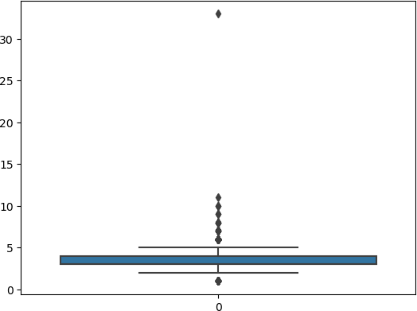

In [13]:

z**=**np**.**abs(stats**.**zscore(df['number of bedrooms']))

In [14]:

threshold**=**3

print(np**.**where(z**>**3),len(np**.**where(z**>**3)[0]))

|  |  |  |  |  |  |  |  |  |  |
| --- | --- | --- | --- | --- | --- | --- | --- | --- | --- |
| (array([ | 76, | 243, | 268, | 275, | 624, | 785, | 1512, | 1519, | 1553, |
|  | 1706, | 2814, | 3109, | 3114, | 3322, | 3532, | 3600, | 4207, | 4486, |
|  | 4658, | 4680, | 6591, | 6596, | 6730, | 6982, | 6998, | 7003, | 7454, |
|  | 8559, | 8650, | 9282, | 9629, | 9810, | 9955, | 10168, | 10177, | 10676, |

10748, 10916, 10944, 11247, 11441, 11547, 11877, 12273, 13048,

13444, 13825, 14220, 14481]),) 49

In [15]:

print(np**.**where(z**<-**3))

(array([], dtype=int64),)

# There are 138 outliers in number of bedrooms as proved from the boxplot and the fact that there are observations whose z- score is beyond 3

In [16]:

df1**=**df[(z**<** 3)]

In [17]:

sns**.**boxplot(df1['number of bedrooms'])

Out[17]:

In [18]:

df1

<AxesSubplot:>

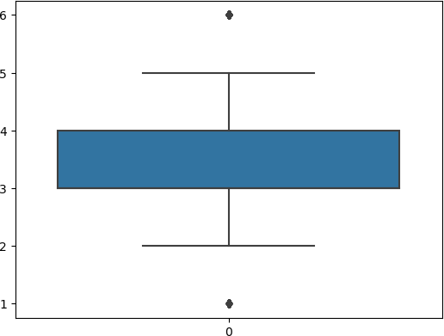

Out[18]:

**number**

**id of**

**number of**

**living**

**lot**

**number**

**of**

**waterfront**

**number**

**of**

**condition**

**of the**

**grade of the**

**... Built**

**Renovation**

**Postal**

|  |  |  |  |  |  |  |  |  |  |
| --- | --- | --- | --- | --- | --- | --- | --- | --- | --- |
|  | **bedrooms bat** | **hrooms** | **area area** | **floors present** | **views** | **house** | **house Year** | **Year** | **Code** |
| **0** | 6762810145 5 | 2.50 | 3650 9050 | 2.0 0 | 4 | 5 | 10 ... 1921 | 0 | 122003 |
| **1** | 6762810635 4 | 2.50 | 2920 4000 | 1.5 0 | 0 | 5 | 8 ... 1909 | 0 | 122004 |
| **2** | 6762810998 5 | 2.75 | 2910 9480 | 1.5 0 | 0 | 3 | 8 ... 1939 | 0 | 122004 |
| **3** | 6762812605 4 | 2.50 | 3310 42998 | 2.0 0 | 0 | 3 | 9 ... 2001 | 0 | 122005 |
| **4** | 6762812919 3 | 2.00 | 2710 4500 | 1.5 0 | 0 | 4 | 8 ... 1929 | 0 | 122006 |
| **...** | ... ... | ... | ... ... | ... ... | ... | ... | ... ... ... | ... | ... |
| **14615** | 6762830250 2 | 1.50 | 1556 20000 | 1.0 0 | 0 | 4 | 7 ... 1957 | 0 | 122066 |
| **14616** | 6762830339 3 | 2.00 | 1680 7000 | 1.5 0 | 0 | 4 | 7 ... 1968 | 0 | 122072 |
| **14617** | 6762830618 2 | 1.00 | 1070 6120 | 1.0 0 | 0 | 3 | 6 ... 1962 | 0 | 122056 |
| **14618** | 6762830709 4 | 1.00 | 1030 6621 | 1.0 0 | 0 | 4 | 6 ... 1955 | 0 | 122042 |
| **14619** | 6762831463 3 | 1.00 | 900 4770 | 1.0 0 | 0 | 3 | 6 ... 1969 | 2009 | 122018 |

14571 rows × 22 columns

In [19]:

sns**.**boxplot(df1['number of bathrooms'])

Out[19]: <AxesSubplot:>

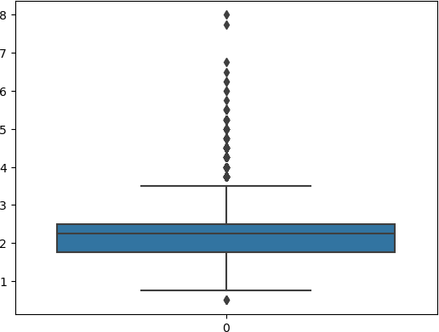

In [20]:

z**=**np**.**abs(stats**.**zscore(df1['number of bathrooms']))

In [21]:

len(np**.**where(z**>**3)[0])

Out[21]: 124

In [22]:

print(np**.**where(z**<-**3))

(array([], dtype=int64),)

In [23]:

df1**=**df1[(z**<** 3)]

In [24]:

sns**.**boxplot(df1['number of bathrooms'])

Out[24]:

In [25]:

df1

<AxesSubplot:>

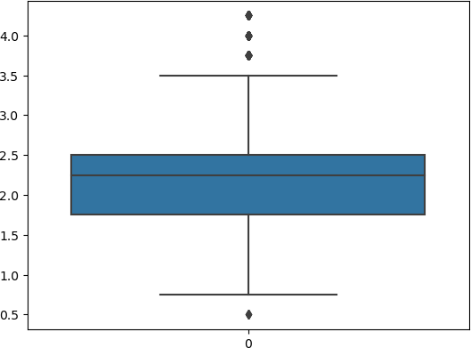

Out[25]:

**number**

**id of**

**number of**

**living**

**lot**

**number**

**of**

**waterfront**

**number**

**of**

**condition**

**of the**

**grade of the**

**... Built**

**Renovation**

**Postal**

|  |  |  |  |  |  |  |  |  |  |
| --- | --- | --- | --- | --- | --- | --- | --- | --- | --- |
|  | **bedrooms bat** | **hrooms** | **area area** | **floors present** | **views** | **house** | **house Year** | **Year** | **Code** |
| **0** | 6762810145 5 | 2.50 | 3650 9050 | 2.0 0 | 4 | 5 | 10 ... 1921 | 0 | 122003 |
| **1** | 6762810635 4 | 2.50 | 2920 4000 | 1.5 0 | 0 | 5 | 8 ... 1909 | 0 | 122004 |
| **2** | 6762810998 5 | 2.75 | 2910 9480 | 1.5 0 | 0 | 3 | 8 ... 1939 | 0 | 122004 |
| **3** | 6762812605 4 | 2.50 | 3310 42998 | 2.0 0 | 0 | 3 | 9 ... 2001 | 0 | 122005 |
| **4** | 6762812919 3 | 2.00 | 2710 4500 | 1.5 0 | 0 | 4 | 8 ... 1929 | 0 | 122006 |
| **...** | ... ... | ... | ... ... | ... ... | ... | ... | ... ... ... | ... | ... |
| **14615** | 6762830250 2 | 1.50 | 1556 20000 | 1.0 0 | 0 | 4 | 7 ... 1957 | 0 | 122066 |
| **14616** | 6762830339 3 | 2.00 | 1680 7000 | 1.5 0 | 0 | 4 | 7 ... 1968 | 0 | 122072 |
| **14617** | 6762830618 2 | 1.00 | 1070 6120 | 1.0 0 | 0 | 3 | 6 ... 1962 | 0 | 122056 |
| **14618** | 6762830709 4 | 1.00 | 1030 6621 | 1.0 0 | 0 | 4 | 6 ... 1955 | 0 | 122042 |
| **14619** | 6762831463 3 | 1.00 | 900 4770 | 1.0 0 | 0 | 3 | 6 ... 1969 | 2009 | 122018 |

14447 rows × 22 columns

# There are 124 outliers in number of bathrooms as proved from the boxplot and the fact that there are observations whose z- score is beyond 3

In [26]:

sns**.**boxplot(df1['living area'])

Out[26]: <AxesSubplot:>

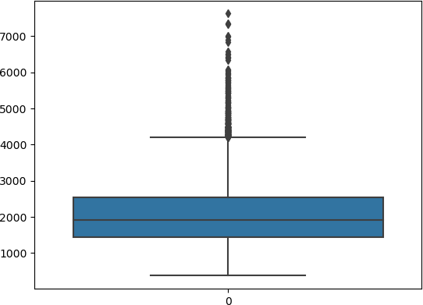

In [27]:

z**=**np**.**abs(stats**.**zscore(df1['living area']))

In [28]:

len(np**.**where(z**>**3)[0])

Out[28]: 136

In [29]:

len(np**.**where(z**<-**3)[0])

Out[29]: 0

In [30]:

df1**=**df1[(z**<**3)]

In [31]:

sns**.**boxplot(df1['living area'])

Out[31]:

In [32]:

z**=**np**.**abs(stats**.**zscore(df1['living area']))

<AxesSubplot:>

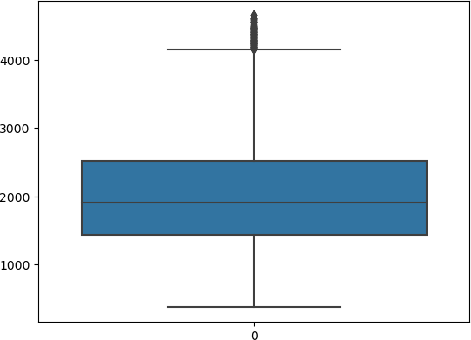

In [33]:

len(np**.**where(z**>**3)[0])

Out[33]: 67

In [34]:

df1**=**df1[(z**<**3)]

In [35]:

sns**.**boxplot(df1['living area'])

Out[35]: <AxesSubplot:>

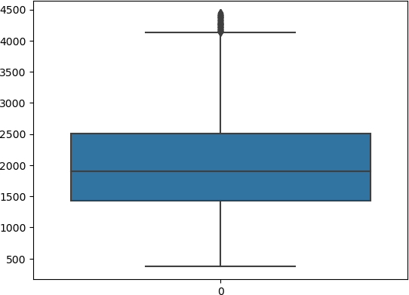

In [36]:

df1

Out[36]:

**number**

**id of**

**number of**

**living**

**lot**

**number**

**of**

**waterfront**

**number**

**of**

**condition**

**of the**

**grade of the**

**... Built**

**Renovation**

**Postal**

|  |  |  |  |  |  |  |  |  |  |
| --- | --- | --- | --- | --- | --- | --- | --- | --- | --- |
|  | **bedrooms bat** | **hrooms** | **area area** | **floors present** | **views** | **house** | **house Year** | **Year** | **Code** |
| **0** | 6762810145 5 | 2.50 | 3650 9050 | 2.0 0 | 4 | 5 | 10 ... 1921 | 0 | 122003 |
| **1** | 6762810635 4 | 2.50 | 2920 4000 | 1.5 0 | 0 | 5 | 8 ... 1909 | 0 | 122004 |
| **2** | 6762810998 5 | 2.75 | 2910 9480 | 1.5 0 | 0 | 3 | 8 ... 1939 | 0 | 122004 |
| **3** | 6762812605 4 | 2.50 | 3310 42998 | 2.0 0 | 0 | 3 | 9 ... 2001 | 0 | 122005 |
| **4** | 6762812919 3 | 2.00 | 2710 4500 | 1.5 0 | 0 | 4 | 8 ... 1929 | 0 | 122006 |
| **...** | ... ... | ... | ... ... | ... ... | ... | ... | ... ... ... | ... | ... |
| **14615** | 6762830250 2 | 1.50 | 1556 20000 | 1.0 0 | 0 | 4 | 7 ... 1957 | 0 | 122066 |
| **14616** | 6762830339 3 | 2.00 | 1680 7000 | 1.5 0 | 0 | 4 | 7 ... 1968 | 0 | 122072 |
| **14617** | 6762830618 2 | 1.00 | 1070 6120 | 1.0 0 | 0 | 3 | 6 ... 1962 | 0 | 122056 |
| **14618** | 6762830709 4 | 1.00 | 1030 6621 | 1.0 0 | 0 | 4 | 6 ... 1955 | 0 | 122042 |
| **14619** | 6762831463 3 | 1.00 | 900 4770 | 1.0 0 | 0 | 3 | 6 ... 1969 | 2009 | 122018 |

14244 rows × 22 columns

# There are 205 outliers in living as proved from the boxplot and the fact that there are observations whose z-score is beyond 3

In [37]:

sns**.**boxplot(df1['number of floors'])

Out[37]: <AxesSubplot:>

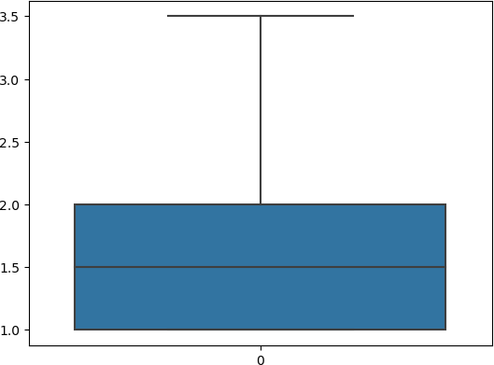

In [38]:

z**=**np**.**abs(stats**.**zscore(df1['number of floors']))

In [39]:

len(np**.**where(z**>**3)[0])

Out[39]: 3

In [40]:

df1**=**df1[(z**<**3)]

In [41]:

sns**.**boxplot(df1['number of floors'])

Out[41]: <AxesSubplot:>

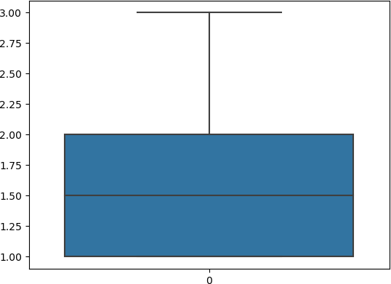

# There are 3 outliers in number of floors

In [42]:

sns**.**boxplot(df1['Price'])

Out[42]: <AxesSubplot:>

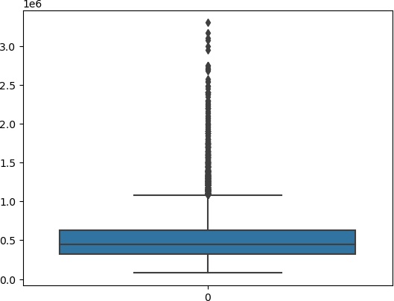

In [43]:

z**=**np**.**abs(stats**.**zscore(df1['Price']))

In [44]:

len(np**.**where(z**>**3)[0])

Out[44]: 259

In [45]:

df1**=**df1[(z**<**3)]

In [46]:

df1

Out[46]:

**number**

**id of**

**number of**

**living**

**lot**

**number**

**of**

**waterfront**

**number**

**of**

**condition**

**of the**

**grade of the**

**... Built**

**Renovation**

**Postal**

|  |  |  |  |  |  |  |  |  |  |
| --- | --- | --- | --- | --- | --- | --- | --- | --- | --- |
|  | **bedrooms bat** | **hrooms** | **area area** | **floors present** | **views** | **house** | **house Year** | **Year** | **Code** |
| **2** | 6762810998 5 | 2.75 | 2910 9480 | 1.5 0 | 0 | 3 | 8 ... 1939 | 0 | 122004 |
| **3** | 6762812605 4 | 2.50 | 3310 42998 | 2.0 0 | 0 | 3 | 9 ... 2001 | 0 | 122005 |
| **4** | 6762812919 3 | 2.00 | 2710 4500 | 1.5 0 | 0 | 4 | 8 ... 1929 | 0 | 122006 |
| **5** | 6762813105 3 | 2.50 | 2600 4750 | 1.0 0 | 0 | 4 | 9 ... 1951 | 0 | 122007 |
| **6** | 6762813157 5 | 3.25 | 3660 11995 | 2.0 0 | 2 | 3 | 10 ... 2006 | 0 | 122008 |
| **...** | ... ... | ... | ... ... | ... ... | ... | ... | ... ... ... | ... | ... |
| **14615** | 6762830250 2 | 1.50 | 1556 20000 | 1.0 0 | 0 | 4 | 7 ... 1957 | 0 | 122066 |
| **14616** | 6762830339 3 | 2.00 | 1680 7000 | 1.5 0 | 0 | 4 | 7 ... 1968 | 0 | 122072 |
| **14617** | 6762830618 2 | 1.00 | 1070 6120 | 1.0 0 | 0 | 3 | 6 ... 1962 | 0 | 122056 |
| **14618** | 6762830709 4 | 1.00 | 1030 6621 | 1.0 0 | 0 | 4 | 6 ... 1955 | 0 | 122042 |
| **14619** | 6762831463 3 | 1.00 | 900 4770 | 1.0 0 | 0 | 3 | 6 ... 1969 | 2009 | 122018 |

13982 rows × 22 columns

In [47]:

df1**=**df1**.**drop(['Renovation Year'],axis**=**1)

In [48]:

df1

Out[48]:

**number**

**id of**

**number of**

**living**

**lot**

**number**

**of**

**waterfront**

**number**

**of**

**condition**

**of the**

**grade of the**

**...**

**Area of**

**the**

**Built**

**Postal**

|  |  |  |  |  |  |  |  |  |  |
| --- | --- | --- | --- | --- | --- | --- | --- | --- | --- |
|  | **bedrooms bat** | **hrooms** | **area area** | **floors present** | **views** | **house** | **house basement** | **Year** | **Code** |
| **2** | 6762810998 5 | 2.75 | 2910 9480 | 1.5 0 | 0 | 3 | 8 ... 0 | 1939 | 122004 |
| **3** | 6762812605 4 | 2.50 | 3310 42998 | 2.0 0 | 0 | 3 | 9 ... 0 | 2001 | 122005 |
| **4** | 6762812919 3 | 2.00 | 2710 4500 | 1.5 0 | 0 | 4 | 8 ... 830 | 1929 | 122006 |
| **5** | 6762813105 3 | 2.50 | 2600 4750 | 1.0 0 | 0 | 4 | 9 ... 900 | 1951 | 122007 |
| **6** | 6762813157 5 | 3.25 | 3660 11995 | 2.0 0 | 2 | 3 | 10 ... 0 | 2006 | 122008 |
| **...** | ... ... | ... | ... ... | ... ... | ... | ... | ... ... ... | ... | ... |
| **14615** | 6762830250 2 | 1.50 | 1556 20000 | 1.0 0 | 0 | 4 | 7 ... 0 | 1957 | 122066 |
| **14616** | 6762830339 3 | 2.00 | 1680 7000 | 1.5 0 | 0 | 4 | 7 ... 0 | 1968 | 122072 |
| **14617** | 6762830618 2 | 1.00 | 1070 6120 | 1.0 0 | 0 | 3 | 6 ... 0 | 1962 | 122056 |
| **14618** | 6762830709 4 | 1.00 | 1030 6621 | 1.0 0 | 0 | 4 | 6 ... 0 | 1955 | 122042 |
| **14619** | 6762831463 3 | 1.00 | 900 4770 | 1.0 0 | 0 | 3 | 6 ... 0 | 1969 | 122018 |

13982 rows × 21 columns

BI - VARIATE ANALYSIS

# The column Renovation year have been removed. This is because most of the Renovation Year are 0 and proves to be of no use to the model

In [49]:

sns**.**barplot(data**=**df1,x**=**'number of bedrooms',y**=**'Price')

Out[49]:

In [50]:

sns**.**barplot(data**=**df1,x**=**'number of bathrooms',y**=**'Price')

<AxesSubplot:xlabel='number of bedrooms', ylabel='Price'>

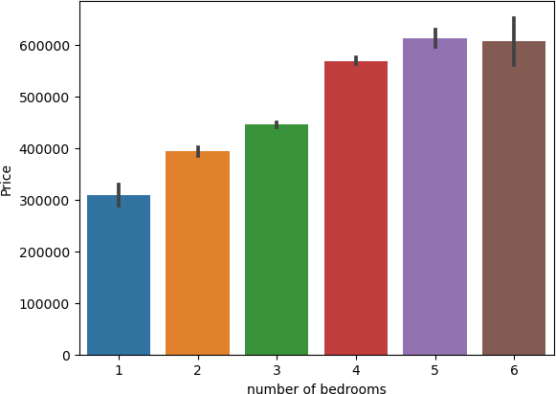

# Clear indication of Price increasing with number of bedrooms

Out[50]: <AxesSubplot:xlabel='number of bathrooms', ylabel='Price'>

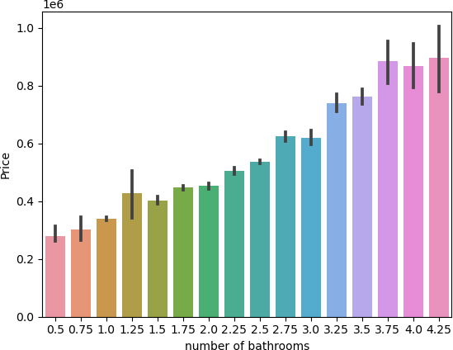

# Clear indication of Price increasing with number of bathrooms

In [51]:

plt**.**figure(figsize**=**(12,18))

sns**.**countplot(data**=**df1,y**=**'Built Year') plt**.**show()

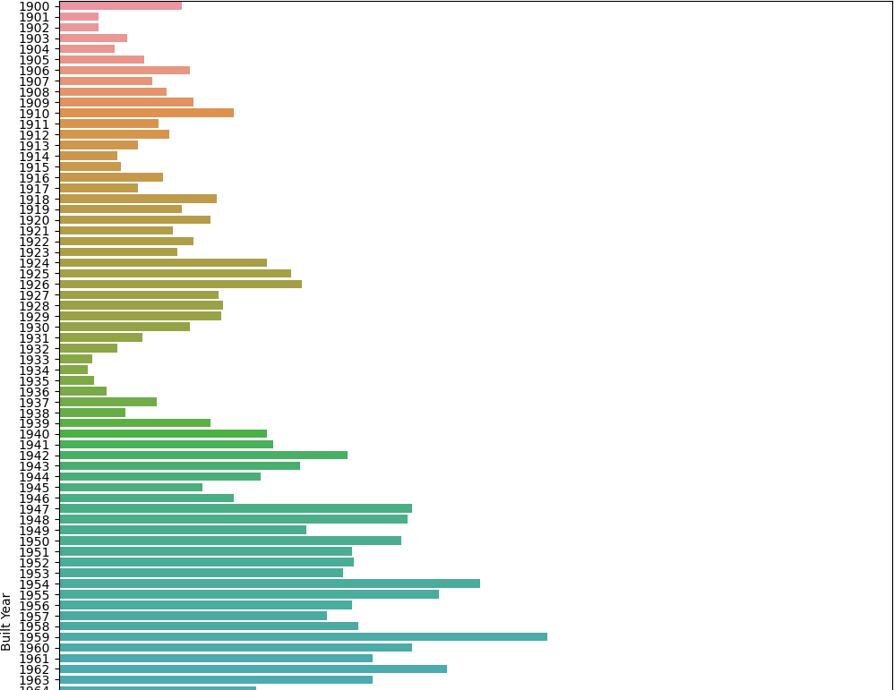

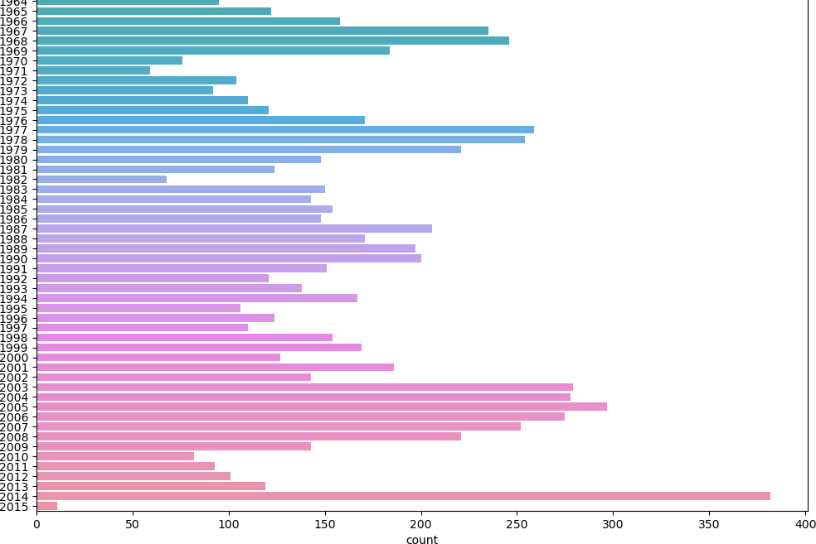

# Most of the houses were listed for sale in 2017

In [52]:

plt**.**figure(figsize**=**(12,18))

sns**.**countplot(data**=**df1,y**=**'Postal Code') plt**.**show()

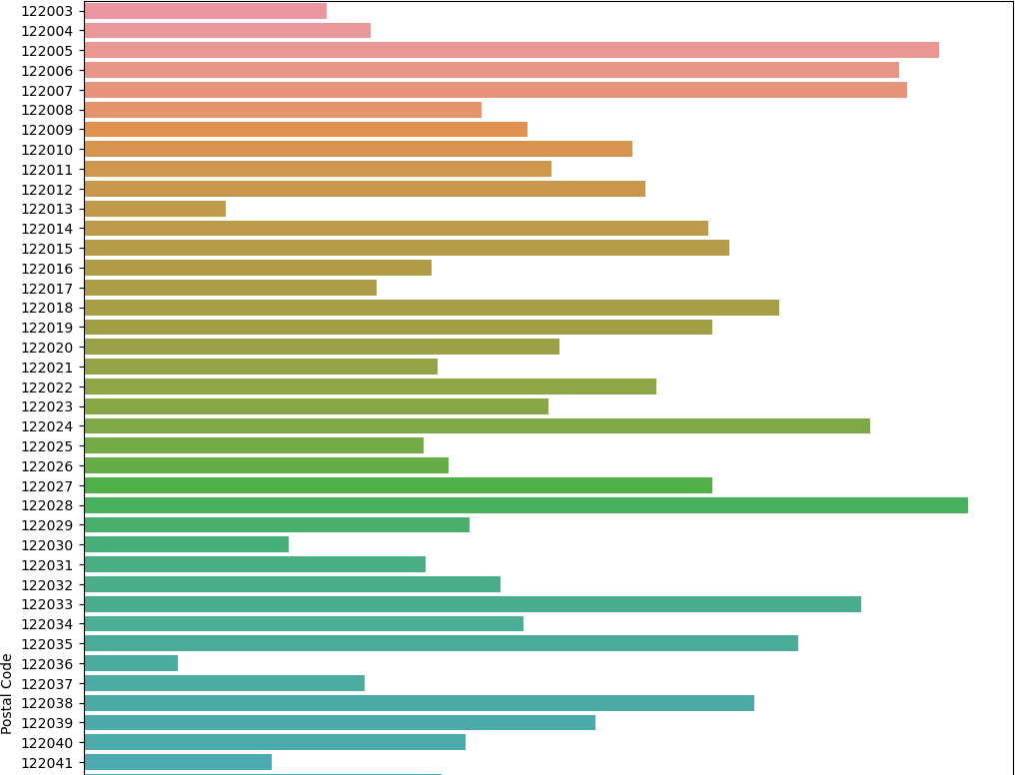

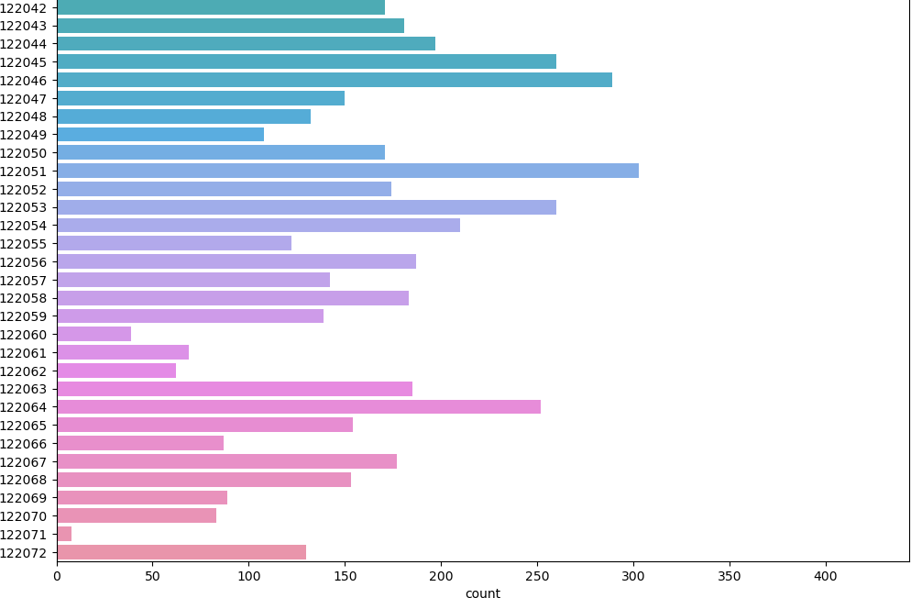

# Most of the houses listed for sale are from the Pincode 122028

In [53]:

df1[df1['Built Year']**==**2014]['Lattitude']**.**mean()

Out[53]: 52.77583376963351

In [54]:

df1[df1['Built Year']**==**2014]['Longitude']**.**mean()

Out[54]: -114.38898952879582

In [55]:

m **=** folium**.**Map(location **=** [52.77, **-**114.4], tiles **=**'OpenStreetMap', zoom_start**=**8)

**for** index, location_info **in** df1[(df1['Built Year']**==**2014) **&** (df1['Distance from the airport']**<=**70)]**.**iterrows():

folium**.**Marker([location_info["Lattitude"], location_info["Longitude"]], popup**=**location_info["Price"],icon**=**folium**.**Icon(colo

m

Out[55]:

o load map: File -> Trust Notebook

Make this Notebook Trusted t

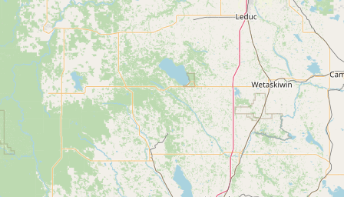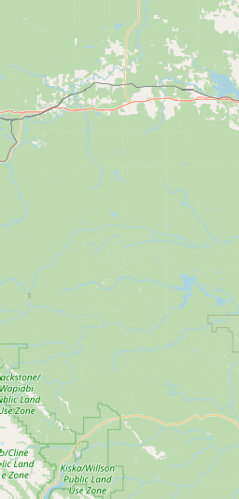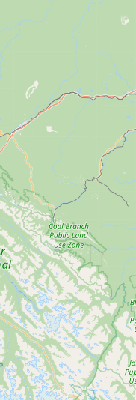

+

## −

[Leaflet (https://leafletjs.com)](https://leafletjs.com/) | Data by © [OpenStreetMap (http://openstreetmap.org)](http://openstreetmap.org/), under [ODbL (http://www.openstreetmap.org/copyright)](http://www.openstreetmap.org/copyright).

In [56]:

df1[df1['Built Year']**>=**2014]['Lattitude']**.**mean()

Out[56]: 52.77850305343512

In [57]:

df1[df1['Built Year']**>=**2014]['Longitude']**.**mean()

Out[57]: -114.39186768447837

In [58]:

m **=** folium**.**Map(location **=** [52.77, **-**114.4], tiles **=**'OpenStreetMap', zoom_start**=**8)

**for** index, location_info **in** df1[(df1['Built Year']**>=**2014) **&** (df1['Distance from the airport']**<=**70)]**.**iterrows():

folium**.**Marker([location_info["Lattitude"], location_info["Longitude"]], popup**=**location_info["Price"],icon**=**folium**.**Icon(colo

m

Out[58]:

o load map: File -> Trust Notebook

Make this Notebook Trusted t



+

## −

[Leaflet (https://leafletjs.com)](https://leafletjs.com/) | Data by © [OpenStreetMap (http://openstreetmap.org)](http://openstreetmap.org/), under [ODbL (http://www.openstreetmap.org/copyright)](http://www.openstreetmap.org/copyright).

# The houses listed for sale in this dataset are located in Alberta, Canada

In [59]:

df1**=**df1**.**drop(['id'],axis**=**1)

In [60]:

df1**=**df1**.**drop(['Postal Code'],axis**=**1)

MULTI - VARIATE ANALYSIS

# Columns ID and Postal Code have been dropped from df as an increase or decrease in Postal Code shall not directly impact the Price of the property

In [61]:

plt**.**figure(figsize**=**(15,15))

sns**.**heatmap(df1**.**corr(),linewidths**=**0.5,annot**=True**,cmap**=**'Blues') plt**.**show()

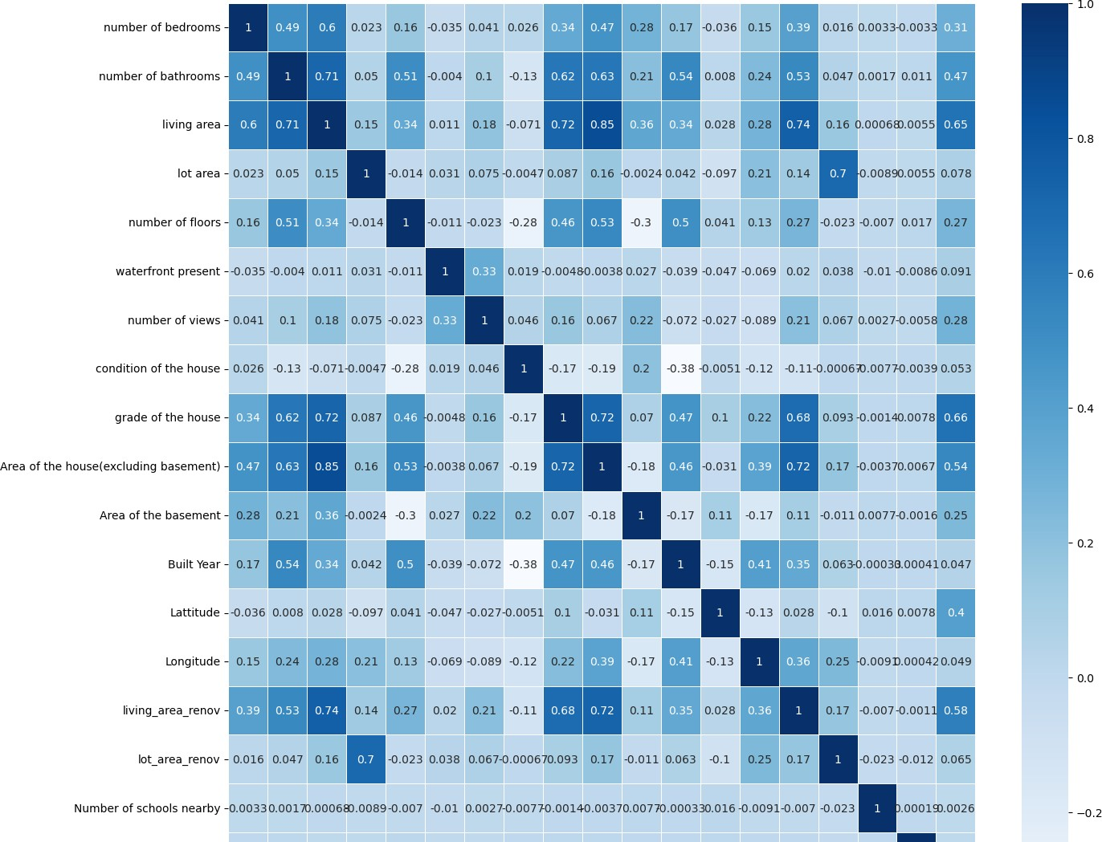

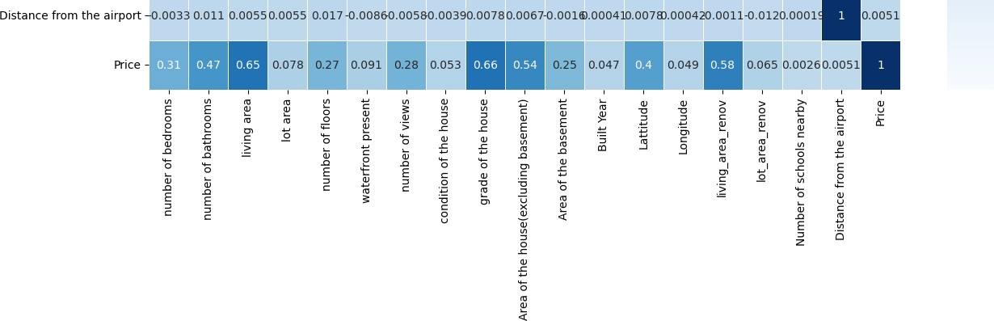

# Columns like 'lot area','condition of the house','Built Year','lot_area_renov','Number of schools nearby','Distance

**from the airport','Longitude' contribute minimal to Price which is the Target variable. Hence it is removed before training**

In [62]:

df1**=**df1**.**drop(['lot area','condition of the house','Built Year','lot_area_renov','Number of schools nearby','Distance from the

In [63]:

plt**.**figure(figsize**=**(15,15))

sns**.**heatmap(df1**.**corr(),linewidths**=**0.5,annot**=True**,cmap**=**'Blues') plt**.**show()

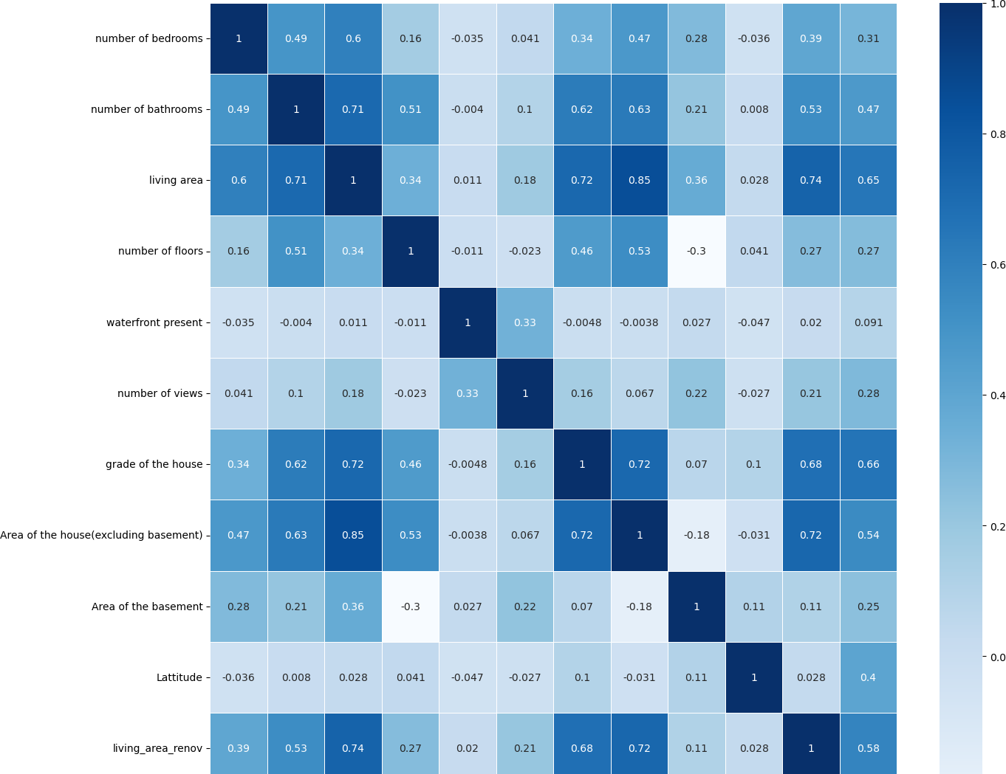

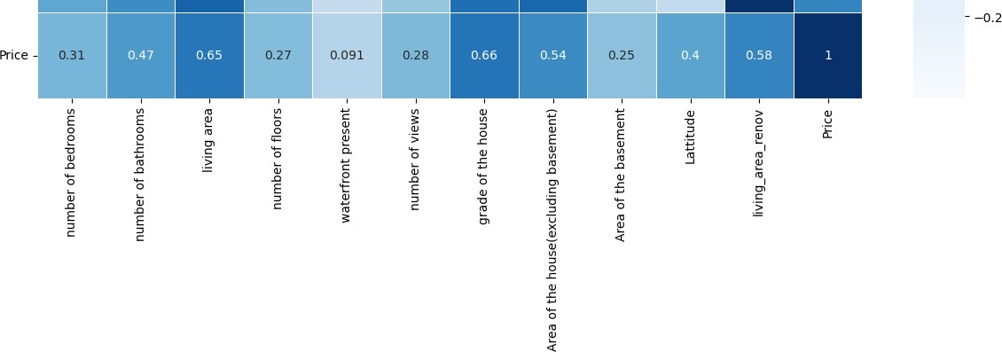

|  |  |  |
| --- | --- | --- |
|  | | **Training of Model, Splitting of Dataset into Train and Test Set** |
| In | [64]: | **from** sklearn.model_selection **import** train_test_split |
|  |  |  |
| In | [65]: | X**=**df1**.**drop(['Price'],axis **=**1) |
|  |  |  |
| In | [66]: | X**.**shape |
| Out[66]: | | (13982, 11) |

In [67]:

y**=**df1['Price']

In [68]:

y**.**shape

Out[68]: (13982,)

In [69]:

X_train,X_test,y_train,y_test**=** train_test_split(X,y,test_size**=**0.2,random_state**=**11)

In [70]:

X_train**.**shape

Out[70]: (11185, 11)

In [71]:

X_test**.**shape

Out[71]: (2797, 11)

In [72]:

**from** sklearn.pipeline **import** make_pipeline

**from** sklearn.preprocessing **import** StandardScaler

**from** sklearn.linear_model **import** ElasticNet, Lasso,LinearRegression,RidgeCV

**from** catboost **import** CatBoostRegressor

**from** sklearn.ensemble **import** RandomForestRegressor, GradientBoostingRegressor

**from** xgboost **import** XGBRegressor

**from** sklearn.tree **import** DecisionTreeRegressor **from** sklearn.ensemble **import** StackingRegressor **from** sklearn.svm **import** SVR

In [73]:

pipelines **=** {

'en':make_pipeline(StandardScaler(), ElasticNet()), 'lasso':make_pipeline(StandardScaler(), Lasso()), 'Rcv':make_pipeline(StandardScaler(), RidgeCV()),

'CatB':make_pipeline(StandardScaler(), CatBoostRegressor(eval_metric**=**'RMSE',verbose**=**1000)), 'lr':make_pipeline(StandardScaler(), LinearRegression()),

'rf':make_pipeline(StandardScaler(), RandomForestRegressor()),

'gb':make_pipeline(StandardScaler(), GradientBoostingRegressor()), 'dtc':make_pipeline(StandardScaler(),DecisionTreeRegressor()),

'xg':make_pipeline(StandardScaler(),XGBRegressor())

}

In [74]:

fit_models **=** {}

**for** algo, pipeline **in** pipelines**.**items():

model **=** pipeline**.**fit(X_train, y_train) fit_models[algo] **=** model

/opt/conda/lib/python3.7/site-packages/sklearn/linear_model/_coordinate_descent.py:648: ConvergenceWarning: Objective did not c onverge. You might want to increase the number of iterations, check the scale of the features or consider increasing regularisa tion. Duality gap: 4.781e+12, tolerance: 5.929e+10

coef_, l1_reg, l2_reg, X, y, max_iter, tol, rng, random, positive

Learning rate set to 0.05996

|  |  |  |  |
| --- | --- | --- | --- |
| 0: | learn: 221490.1496581 | total: 61.4ms | remaining: 1m 1s |
| 999: | learn: 77595.2298921 | total: 2.85s | remaining: 0us |

In [75]:

**from** sklearn.metrics **import** mean_absolute_error, mean_squared_error maes**=**[]

al**=**[]

**for** algo, model **in** fit_models**.**items(): yhat **=** model**.**predict(X_test)

al**.**append(algo)

maes**.**append(mean_squared_error(y_test,yhat)**\*\***0.5)

print(algo,'MEAN ABSOLUTE ERROR', mean_absolute_error(y_test,yhat))

print(algo,'ROOT MEAN SQUARED ERROR',mean_squared_error(y_test,yhat)**\*\***0.5)

en MEAN ABSOLUTE ERROR 104444.32355671145

en ROOT MEAN SQUARED ERROR 140011.53917862213 lasso MEAN ABSOLUTE ERROR 97479.23118789196

lasso ROOT MEAN SQUARED ERROR 132916.1566456281 Rcv MEAN ABSOLUTE ERROR 97481.91673717603

Rcv ROOT MEAN SQUARED ERROR 132918.333682342 CatB MEAN ABSOLUTE ERROR 66637.30790160663

CatB ROOT MEAN SQUARED ERROR 97508.34029611414 lr MEAN ABSOLUTE ERROR 97574.48622571728

lr ROOT MEAN SQUARED ERROR 132952.7515959945 rf MEAN ABSOLUTE ERROR 69217.89879907611

rf ROOT MEAN SQUARED ERROR 102292.3632979867 gb MEAN ABSOLUTE ERROR 69874.84067217445

gb ROOT MEAN SQUARED ERROR 101056.41447857216 dtc MEAN ABSOLUTE ERROR 96944.72285782386

dtc ROOT MEAN SQUARED ERROR 143316.21683052482 xg MEAN ABSOLUTE ERROR 69035.05210660976

xg ROOT MEAN SQUARED ERROR 100694.41040458805

In [76]:

plt**.**figure(figsize**=**(5,5))

plt**.**xlabel('ML Algorithms...')

plt**.**ylabel('Root Mean Squared Errors...') ax**=**sns**.**barplot(x**=**al,y**=**maes)

plt**.**show()

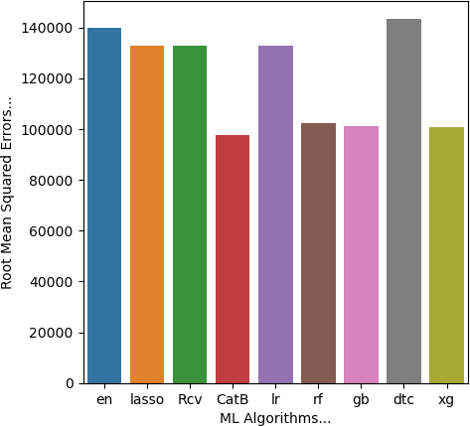

In [ ]:

CatB **=** CatBoostRegressor(verbose**=**1000,eval_metric**=**'RMSE') rf **=** RandomForestRegressor()

gb **=** GradientBoostingRegressor() xg **=** XGBRegressor()

lr**=**LinearRegression()

stregr **=** StackingRegressor(estimators**=**[('catb',CatB),('xg', xg),('gb',gb)],

final_estimator**=**lr)

pipeline **=** make_pipeline( StandardScaler(),

stregr

)

pipeline**.**fit(X_train, y_train)

*# Generate predictions on the test set*

y_pred **=** pipeline**.**predict(X_test)

*# Evaluate the model*

print("Root Mean Squared Error: %.4f" **%** mean_squared_error(y_test,y_pred)**\*\***0.5)

|  |  |  |  |  |  |
| --- | --- | --- | --- | --- | --- |
| Learning rate set to 0.05996 | | | | | |
| 0: | learn: 221490.1496581 | total: | 4.18ms | remaining: | 4.18s |
| 999: | learn: 77595.2298921 | total: | 2.81s | remaining: | 0us |
| Learning rate set to 0.057883 | | | | | |
| 0: | learn: 222091.4863333 | total: | 3.52ms | remaining: | 3.51s |
| 999: | learn: 76337.1933964 | total: | 2.52s | remaining: | 0us |
| Learning rate set to 0.057883 | | | | | |
| 0: | learn: 222546.8538661 | total: | 2.94ms | remaining: | 2.94s |
| 999: | learn: 75466.5961681 | total: | 2.51s | remaining: | 0us |
| Learning rate set to 0.057883 | | | | | |
| 0: | learn: 223455.5230951 | total: | 3.2ms | remaining: | 3.2s |
| 999: | learn: 75656.3661258 | total: | 2.52s | remaining: | 0us |
| Learning rate set to 0.057883 | | | | | |
| 0: | learn: 221606.9467960 | total: | 3.71ms | remaining: | 3.7s |
| 999: | learn: 75195.9699196 | total: | 2.46s | remaining: | 0us |
| Learning rate set to 0.057883 | | | | | |

0: learn: 219316.0911020 total: 2.47ms remaining: 2.47s

In [ ]:

mean_squared_error(y_test,y_pred)**\*\***0.5

In [ ]:

al**.**append('stacked model')

maes**.**append(mean_squared_error(y_test,y_pred)**\*\***0.5)

In [ ]:

**for** i **in** range(10):

print("The RMSE of",al[i],'is',maes[i])

In [ ]:

plt**.**figure(figsize**=**(9,5))

plt**.**xlabel('ML Algorithms...')

plt**.**ylabel('Root Mean Squared Errors...') ax**=**sns**.**barplot(x**=**al,y**=**maes)

plt**.**show()

ALL DONE BY SURYA AS NAAN MUDALVAN IBM SMARTINTERNZ ASSIGNMENT 3